**Singleton Class**

A class such that only one object is created if a object of this class is used in different places then the same object should be used

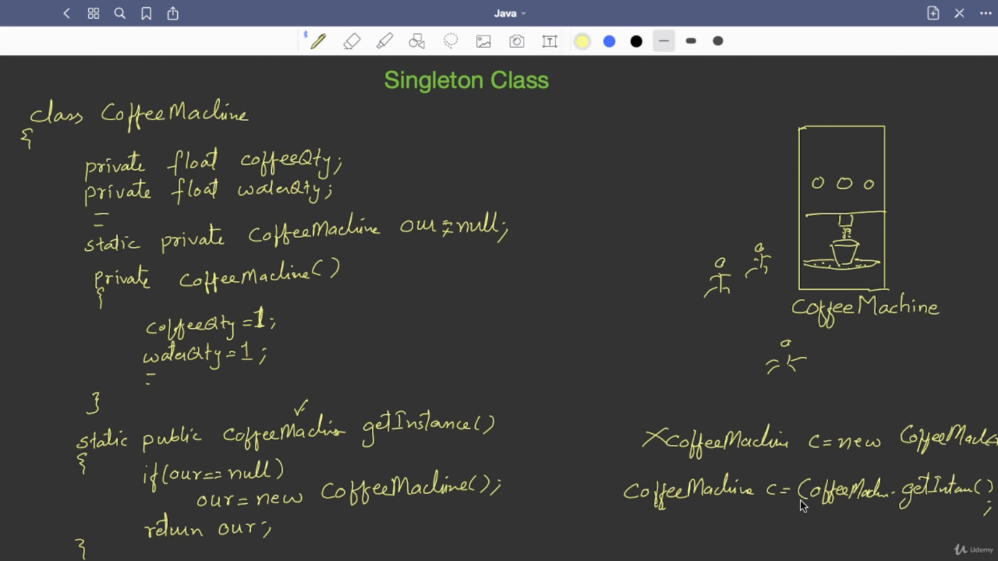

Code:

|  |
| --- |
| package singleton; |
|  |  |
|  |  |
|  | class CoffeeMachine |
|  | { |
|  | private float coffeQty; |
|  | private float milkQty; |
|  | private float waterQty; |
|  | private float sugarQty; |
|  |  |
|  | static private CoffeeMachine my=null; |
|  |  |
|  | private CoffeeMachine() |
|  | { |
|  | coffeQty=1; |
|  | milkQty=1; |
|  | waterQty=1; |
|  | sugarQty=1; |
|  | } |
|  |  |
|  | public void fillWater(float qty) |
|  | { |
|  | waterQty=qty; |
|  | } |
|  | public void fillSugar(float qty) |
|  | { |
|  | sugarQty=qty; |
|  | } |
|  | public float getCoffee() |
|  | { |
|  | return 0.15f; |
|  | } |
|  |  |
|  | static CoffeeMachine getInstance() |
|  | { |
|  | if(my==null) |
|  | my=new CoffeeMachine(); |
|  | return my; |
|  | } |
|  |  |
|  |  |
|  | } |
|  | public class Singleton |
|  | { |
|  | public static void main(String[] args) |
|  | { |
|  | CoffeeMachine m1=CoffeeMachine.getInstance(); |
|  | CoffeeMachine m2=CoffeeMachine.getInstance(); |
|  | CoffeeMachine m3=CoffeeMachine.getInstance(); |
|  |  |
|  | System.out.println(m1+" "+m2+" "+m3); |
|  | if(m1==m2 && m1==m3) |
|  | System.out.println("Same"); |
|  |  |
|  | } |
|  | } |

You can configure class to create objects of certain amount of times